 | SUMMER CAMP 2026- 69 PAPE JULY 2026 CONTACT: ANGELA 416-645-6000 x1112 or LORI 416-645-6000 x 3501
 | ** Please bring a lunch and two snacks daily and respect our nut-free policy/ changes will be noted daily Hours = 8:30 a.m. – 4:30 p.m. Cost = $130.00/week
 | Monday | Tuesday | Wednesday | Thursday JULY 2 | July 3 Friday
WEEK  1 | JUNE 29  GROUP GAMES  Bingo Games  Jenga  Puzzles | JUNE 30  MORSE PARK 10:00-1:00  BRING SWIMWEAR & TOWEL  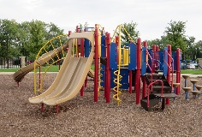 | JULY 1  CLOSED  CANADA DAY  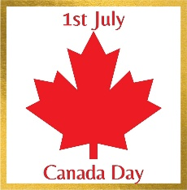 | JULY 2  Jones Park 10:00-1:00  Bring Swimwear and Towel  PLAYDOUGH AND  ARTS AND CRAFTS (PM) | JULY 3  BADMINTON GAME  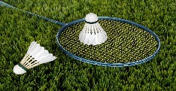  Creative / electronics  BOARD GAMES  COOKING
WEEK  2 | JULY 6  Scavenger Hunt  JEWELERY MAKING  MIND CHALLENGES  PLAYGROUND GAMES | JULY 7  10:00-1:30 WOODBINE PARK  TTC  BRING SWIMWEAR FOR SPLASH PAD | JULY 8  SOCCER game    COMPUTERS IN PM  LEGO CHALLENGE  Clay Art  SCOOP GAME | JULY 9  JONES PARK 10:00-2:00  Bring Swimwear and Towel for Splash Pad  TAG FUN  MINI GOLF COURSE | JULY 10  Movie/Pajama Day at Pape    MAKING NECKLACE WITH BEADS  MAKING FRUIT SALAD
WEEK 3 | JULY 13  CLAY CREATIONS  LEGO CLUB MAKING  TALLEST STRUCTURES  CHALLENGE  SCIENTIST WORKSHOP   | JULY 14  Movie AT pape    BRING TREATS  Dodge Ball on Playground  CARD GAMES  ICE MOLD | JULY 15  Kew Beach 10:00-1:00  Bring Swimwear and Towel  Marshmallows Art  Bubbles  Bean bags toss challenge | JULY 16  COOKING WORKSHOP  MAKING PIZZA 9:30-11:00  FREEZE DANCE CHALLENGE  BUBBLES  Hula Hoop Challenge | July 17  Electronic Day    Bring your own Show and Share  CARD GAMES  BINGO  COOKING  Hopscotch
WEEK 4 | JULY 20  COMPUTERS  LEGO FUN CONTEST  Art: MARBLE PAINTING  PLAYGROUND  SCIENCE FUN | JULY 21  LEGO LAND  TRIP  9:30-2:00  VAUGHAN MILL | July 22  10:00 -11:30 Baking cupcakes    PLAYGROUND SOCCER GAME  Make soda float | JULY 23  MORSE PARK 10:00-1:00  Bring Swimwear and Towel  BUILDING SANDCASTLES  DECORATING CUPCAKES  Scavenger hunt | JULY 24  Cupcake sale - $$$    Games/computers  Making slime  LEGO  SUN MELTED CRAYONS ART

