 | SUMMER CAMP 2026- 69 PAPE AUGUST 2026 CONTACT: ANGELA 416-645-6000 x1112 or LORI 416-645-6000 x 3501
 | ** Please bring a lunch and two snacks daily and respect our nut-free policy / changes will be noted daily Hours = 8:30 a.m. – 4:30 p.m. Cost = $130.00/week
 | Monday | Tuesday | Wednesday | Thursday | Friday
WEEK  5 | July 27  SCIENCE WORKSHOP    OUTDOOR GROUP GAMES  SLIME MAKING DAY | July 28  RIVERDALE FARM TRIP/TTC  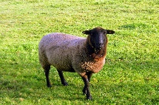  TTC  Bring swimwear and towel/Picnic lunch | July 29  Face painting  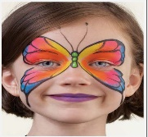  Sports day / BINGO GAME | July 30  JIMMIE SIMPSON  Bring swimwear and towel  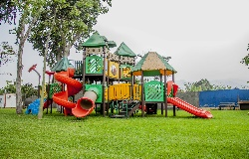  Computers in pm  WATER BALLOON TOSS | July 31  Comic strips  CLAY ART  RAINBOW LOOM CRAFTS  COOKING WORKSHOP  
WEEK  6 | August 3  STATUTORY HOLIDAY  PROGRAM CLOSED | August 4  BADMINTON  PLAYGROUND ART Bubble/Water Fun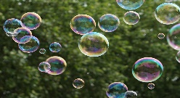  Bring swimwear and towel  Computers and Games | August 5  Skyzone- Vaughan Mills- BUS  9:30-2:00 | August 6  DIY Kite Workshop  Create a Story: Mad Libs  Sand Art  Water Sensory Play | August 7  BACKWARDS TSHIRT DAY  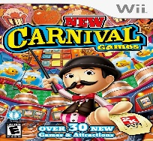  LEGO CHALLENGE  Movie/popcorn-on site / WEAR PJ’S
WEEK  7 | August 10  ARTS AND CRAFTS ON  PLAYGROUND  HULA HOOP CONTEST  Bingo contest  Soccer Game | August 11  MOVIE  Bring snacks- Movies  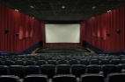  Slime day  Cards | August 12  Jones Park 10:00-1:00  Computer Games  Spray bottle paintings  HANDPRINT PAINTINGS | August 13  JIMMIE SIMPSON PARK  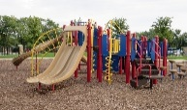  Bring Swimwear for splash pad  Play capture the flag | August 14  PLAYGROUND FUN DAY  CHALK DRAWING  BALLOONS TOSS  BUBBLES/BEACH BALLS  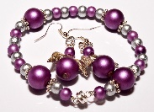  Jewelery Making
WEEK 8 | August 17  Art activity: Poke Ball plate craft  Chalk drawing challenge | August 18  Reptilia Zoo-Whitby-BUS  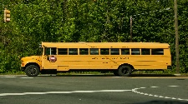  MAKING NECKLACES | August 19  10:00-11:00 Science Workshop  MELTY BEAD ART  MAKING LUNCH AND CUPCAKES  CAPTURE THE FLAG | August 20  Morse Park 10-11:30  BUBBLES, WATER BALLONS  DECORATING CUPCAKES  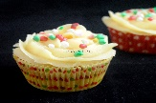 | August 21  Last Day of summer camp  Party and Dancing  Bring Treats

